HONORS CHEMISTRY • UNIT 5
Moles and Molar Quantities
Count particles by the mole, then connect particles, grams and gas volume through molar mass.

HOW TO USE THIS PACKET
Write in pencil. For every calculation show the given with its unit, each conversion factor as a fraction so the units cancel, and the answer with units and the right number of significant figures. Use molar masses to 0.01 g/mol, Avogadro’s number 6.022 × 10²³ and 22.4 L/mol for a gas at STP. Every conversion goes through moles. Extra practice is at the back.

What we will learn
 | Topic
5.1 | The mole and Avogadro’s number
5.2 | Molar mass
5.3 | Mole conversions (particles, moles and grams)
5.4 | Volume of a gas at STP
5.5 | Percent composition
5.6 | Empirical and molecular formulas
5.7 | Hydrates

By the end of this unit I can…
• Explain what a mole is and use Avogadro’s number to convert between particles and moles.
• Find the molar mass of an element or compound, including formulas with parentheses.
• Convert between particles, moles and grams using the mole map, showing every unit.
• Use 22.4 L/mol to convert between moles, grams, particles and the volume of a gas at STP.
• Calculate the percent composition by mass of a compound.
• Find an empirical formula from masses or percentages, and a molecular formula from the molar mass.
• Use the mass lost on heating to find the formula and name of a hydrate.

5.1 | The Mole and Avogadro’s Number Counting by the mole • 6.022 × 10²³ • atoms, molecules and formula units

BIG IDEA
Atoms and molecules are far too small to count one at a time, so chemists count them in huge groups called moles. 1 mole = 6.022 × 10²³ particles, just as 1 dozen = 12. A mole is a number, not a mass.

Key vocabulary — write each definition in your own words
Term | Definition (your words) | Example / sketch
Mole | What is it, and what does it measure?
Avogadro’s number | Write the value in scientific notation. What does it count?
Particle | Name the three kinds of particles and say which substances each goes with.

HOW TO CONVERT BETWEEN PARTICLES AND MOLES
1. Decide what the particles are: atoms, molecules or formula units.
2. Write 1 mol = 6.022 × 10²³ particles as a fraction so the unit you start with cancels.
3. Moles to particles: multiply by 6.022 × 10²³. Particles to moles: divide by 6.022 × 10²³.
4. Round to the sig figs of the data and write the unit.

WORKED EXAMPLE
How many atoms are in 2.50 mol of magnesium?

Work it out here:

1. What is a “mole” in chemistry, and what is it used to measure?

2. What is the difference between an atom and a molecule?

Convert (show the fraction setup)
 | Particles and moles
3. | How many atoms are in 1.75 moles of aluminum?
4. | How many molecules are in 3.25 moles of H₂O?
5. | How many moles are in 3.4 × 10²⁶ molecules of CO₂?
6. | How many moles are there in 3.88 × 10²⁵ atoms of nickel?

1. Which sample contains the most particles?
A) 1 mol of iron B) 1 mol of water C) 1 mol of helium D) They all contain the same number
2. How many oxygen atoms are in 1 mol of O₂ molecules?
A) 6.022 × 10²³ B) 1.204 × 10²⁴ C) 3.011 × 10²³ D) 32
5.2 | Molar Mass Grams per mole • add the atomic masses • subscripts and parentheses

BIG IDEA
The molar mass of a substance is the mass of 1 mole of it, in g/mol. For a compound, add the atomic masses of every atom in the formula. Molar mass is the bridge between grams and moles.

HOW TO FIND A MOLAR MASS
1. List each element in the formula and count its atoms. A subscript outside parentheses multiplies everything inside: in Mg(OH)₂ there are 2 O and 2 H.
2. Multiply each count by the atomic mass (to 0.01 g/mol).
3. Add the results. Round to 0.01 g/mol and write the unit g/mol.

WORKED EXAMPLE
Find the molar mass of aluminum sulfate, Al₂(SO₄)₃.

Work it out here:

Key vocabulary — write each definition in your own words
Term | Definition (your words) | Example / sketch
Molar mass | What does it measure, and what unit does it have?
Diatomic element | Name the seven that exist as pairs of atoms.

1. Define molar mass in your own words.

Calculate the molar mass of each substance (show the sum)
 | Formula | Work and molar mass (g/mol)
1. | Be
2. | N₂
3. | O₂
4. | F₂
5. | Mg
6. | Ag
7. | LiI
8. | PbCO₃
9. | Mg(OH)₂
10. | K₃PO₄
11. | (NH₄)₃PO₄
12. | C₆H₁₂O₆

LAB CORNER • Weighing a mole

A student weighs out exactly 1 mole of each of three substances: 18.02 g of water, 58.44 g of table salt (NaCl) and 55.85 g of iron.
1. (a) Which sample contains the most particles? (b) Why are the three masses different?
Answer:

2. What is the molar mass of Ca(OH)₂?
A) 57.09 g/mol B) 74.10 g/mol C) 58.10 g/mol D) 73.09 g/mol
5.3 | Mole Conversions Particles • moles • grams • the mole map

BIG IDEA
You can never go straight from particles to grams. Every conversion goes through moles. The mole map shows which factor to use for each arrow: Avogadro’s number for particles, molar mass for grams.

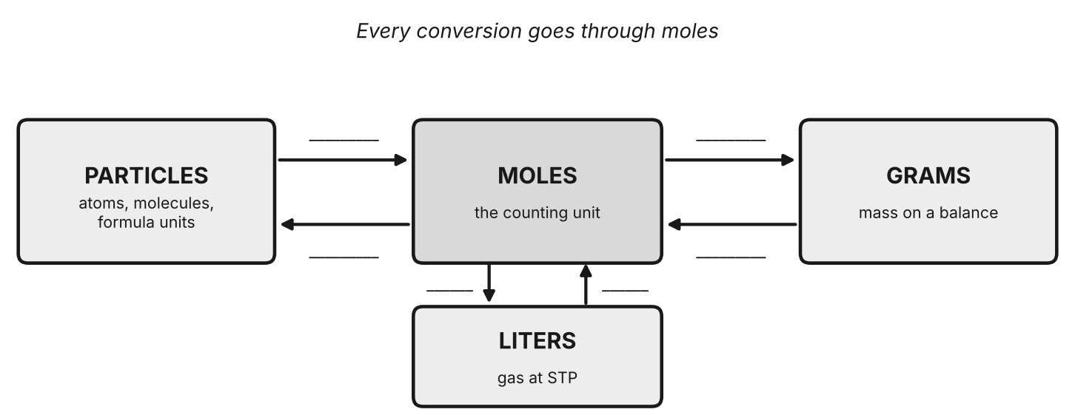
The mole map. Write the conversion factor on each arrow.
STEPS
1. Write the given quantity with its unit.
2. Find the path on the mole map. Grams or particles go to moles first, then on to the answer.
3. Set up each factor as a fraction so the unit you want to remove cancels.
4. Calculate, round to the sig figs of the data, and label the answer with the unit and the substance.

WORKED EXAMPLE
How many molecules are in 9.00 g of water?

Work it out here:

Solve each problem. Show givens, factors and the answer with units.
 | Mole conversion problems
1. | Calculate the number of grams of CO₂ that will contain 2.5 × 10²⁴ molecules of CO₂.
2. | How many moles of carbon tetrafluoride, CF₄, are in 176 grams of CF₄?
3. | How many moles of water are in 360.0 grams of water?
4. | How many moles of iron(III) oxide, Fe₂O₃, are there in 79.85 grams of iron(III) oxide?
5. | How many molecules of chlorine gas, Cl₂, are present in 52.5 grams of Cl₂?
6. | How many copper atoms are present in 5.6 moles of Cu₂O₃?
7. | A student measures out 2.5 moles of glucose, C₆H₁₂O₆. How many grams of oxygen are contained in that amount of glucose?
8. | A student measures out 15.0 grams of CaCl₂. How many grams of chlorine are present?

1. To convert grams of CO₂ to molecules of CO₂, the first step is to…
A) multiply by 6.022 × 10²³ B) divide by the molar mass C) multiply by 22.4 D) divide by 6.022 × 10²³
2. What is the mass of 0.50 mol of H₂O?
A) 9.0 g B) 18 g C) 36 g D) 0.50 g
5.4 | Volume of a Gas at STP 22.4 L/mol • 0 °C and 1 atm • moles, grams and particles

BIG IDEA
At STP (standard temperature and pressure: 0 °C and 1 atm), 1 mole of any gas takes up 22.4 L. That adds one more arrow to the mole map: moles ↔ liters of gas.

Key vocabulary — write each definition in your own words
Term | Definition (your words) | Example / sketch
STP | What do the letters stand for, and what are the two conditions?
Molar volume | How much space does 1 mol of gas fill at STP? Does the kind of gas matter?

STEPS
1. Moles ↔ liters: use 1 mol = 22.4 L (STP only, gases only).
2. If the given is grams or particles, go to moles first with the molar mass or Avogadro’s number.
3. Then use 22.4 L/mol, or go on to grams or particles for the answer.

WORKED EXAMPLE
What volume does 8.00 g of O₂ occupy at STP?

Work it out here:

What volume will each of the following occupy at STP?
 | Volume at STP
1. | 3.20 moles of O₂
2. | 1.75 moles of NH₃
3. | 37.8 moles of CO₂
4. | 5.05 grams of helium
5. | 60.0 grams of xenon

Solve each problem. All gases are at STP.
 | Gas problems at STP
6. | A sample of NH₃ gas occupies 75.3 L at STP. How many molecules is this?
7. | What is the mass of 575 L of ammonia (NH₃) gas at STP?
8. | A 5.00 gram sample of O₂ is in a container at STP. What is the volume of this sample?
9. | How many molecules are present in the container in the question above?
10. | How many molecules are present in 0.12 L of carbon dioxide gas at STP? How many grams?

1. Which has the greatest volume at STP?
A) 1.00 mol of N₂ B) 28.02 g of N₂ C) 6.022 × 10²³ molecules of N₂ D) All three are the same
2. Why can’t you use 22.4 L/mol for a gas at 25 °C?
A) 22.4 L/mol applies only at 0 °C and 1 atm B) The gas has no molar mass at 25 °C C) Moles change with temperature D) 22.4 L/mol is only for noble gases
5.5 | Percent Composition Part ÷ whole × 100 • mass percent of each element

BIG IDEA
Percent composition tells you what part of a compound’s mass comes from each element. The percents of all the elements add up to 100 %.

HOW TO FIND PERCENT COMPOSITION
1. Find the molar mass of the compound (the whole).
2. For each element, find its mass in 1 mole of the compound (atomic mass × subscript): the part.
3. % element = (mass of element in 1 mol ÷ molar mass of compound) × 100.
4. Check that the percents add to 100 (within rounding).

WORKED EXAMPLE
Find the percent composition of calcium carbonate, CaCO₃.

Work it out here:

Find the percent composition of every element in each compound
 | Percent composition
1. | NaOH
2. | CuBr₂
3. | N₂S₂
4. | (NH₄)₂S
5. | (NH₄)₃PO₄

1. A 50.0 g sample of a compound is 20.0 % hydrogen by mass. How many grams of hydrogen are in the sample?
A) 2.5 g B) 10.0 g C) 20.0 g D) 40.0 g
2. Which has the greater percent oxygen by mass?
A) H₂O B) H₂O₂ C) They are the same D) Cannot be told
5.6 | Empirical and Molecular Formulas Simplest whole-number ratio • percent → grams → moles → ratio

BIG IDEA
The empirical formula is the simplest whole-number ratio of atoms in a compound. The molecular formula is the actual number of each atom, and it is a whole-number multiple of the empirical formula: molecular = n × empirical, where n = molar mass ÷ empirical formula mass.

STEPS
1. Change each percent to grams (assume a 100 g sample), or use the grams given.
2. Change each mass to moles (÷ atomic mass).
3. Divide every mole value by the smallest. These are the subscripts.
4. If a result is near x.5, multiply all by 2 (near x.33 or x.67, by 3). Do not round 1.5 up to 2.
5. Molecular formula: n = molar mass ÷ empirical mass; multiply every subscript by n.

WORKED EXAMPLE
A compound is 40.0 % C, 6.7 % H and 53.3 % O and has a molar mass of 180 g/mol. Find its empirical and molecular formulas.

Work it out here:

Solve each problem
 | Empirical and molecular formula problems
1. | Determine the empirical formula of the compound if it contains 87.3 g Na, 121.5 g S and 91.2 g O.
2. | A compound contains 85.65 % Bi, 6.56 % O and 7.79 % F. What is the empirical formula of this compound?
3. | Propene has an empirical formula of CH₂. What is its molecular formula if it has a molar mass of 42.09 g/mol?
4. | The percent composition of an unknown substance is 75.42 % carbon, 6.63 % hydrogen, 8.38 % nitrogen and 9.57 % oxygen. If its molar mass is 334.0 g/mol, what is its empirical and molecular formula?

1. What is the empirical formula of C₆H₁₂O₆?
A) CHO B) CH₂O C) C₂H₄O₂ D) C₆H₁₂O₆
2. A compound has the empirical formula CH and a molar mass of 78 g/mol. Its molecular formula is…
A) CH B) C₂H₂ C) C₆H₆ D) C₆H₁₂
5.7 | Hydrates Water in the crystal • heating • the formula and the name

BIG IDEA
A hydrate is an ionic compound with a fixed number of water molecules built into its crystal, such as CuSO₄ · 5H₂O. Heating drives the water off and leaves the anhydrous (“without water”) salt. The mass lost is the mass of water, so you can compare moles of water to moles of salt.

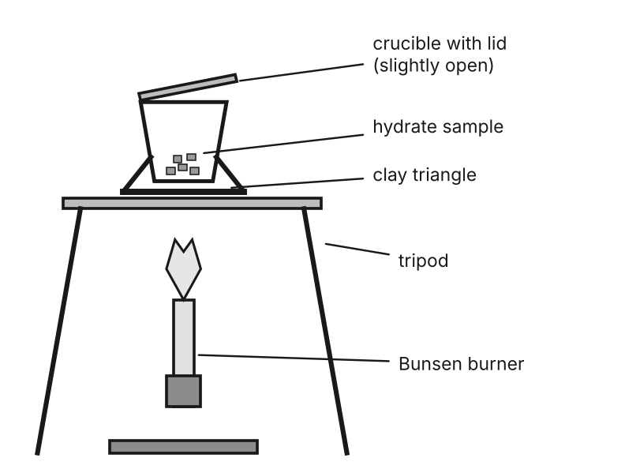
Heating a hydrate in a crucible. Mass the crucible, the hydrate and the anhydrous salt.
1 | 2 | 3 | 4 | 5 | 6 | 7 | 8 | 9 | 10
mono- | di- | tri- | tetra- | penta- | hexa- | hepta- | octa- | nona- | deca-

HOW TO FIND THE FORMULA OF A HYDRATE
1. mass of water = mass of hydrate − mass of anhydrous salt.
2. Change both to moles: water ÷ 18.02 g/mol, salt ÷ its molar mass.
3. x = moles of H₂O ÷ moles of salt (divide by the smaller). Round to the nearest whole number.
4. Write the formula salt · xH₂O and the name salt name + prefix + “hydrate”.

WORKED EXAMPLE
A 7.36 g sample of a hydrate of calcium chloride is heated until no water remains. The CaCl₂ left has a mass of 5.55 g. Find the formula and name of the hydrate.

Work it out here:

Find the formula and the name of each hydrate
 | Hydrate problems
1. | A hydrate of magnesium sulfate has a mass of 13.52 g. This sample is heated until no water remains. The MgSO₄ anhydrate has a mass of 6.60 g. Find the formula and name of the hydrate.
2. | A sample of copper(II) sulfate hydrate has a mass of 3.97 g. After heating, the CuSO₄ that remains has a mass of 2.54 g. Determine the correct formula and name of the hydrate.
3. | A sample of the hydrate of sodium carbonate has a mass of 8.85 g. It loses 1.28 g when heated. Find the formula and the name of the hydrate.
4. | A 16.4 g sample of hydrated calcium sulfate is heated until all the water is driven off. The calcium sulfate that remains has a mass of 13.0 g. Find the formula and the chemical name of the hydrate.
5. | A hydrate is determined to be 45.43 % water and 54.57 % CoCl₂. Find the chemical formula and name for this hydrate. (Hint: assume that there is 100 g total of hydrate compound.)

1. After a hydrate is heated, its mass decreases. The mass lost is the mass of…
A) the salt B) the water C) the crucible D) air
2. Which is the correct name for CoCl₂ · 6H₂O?
A) cobalt chloride hexahydrate B) cobalt(II) chloride hexahydrate C) cobalt(II) chloride sixhydrate D) cobalt(II) chlorate hexahydrate

PRACTICE
Extra Practice — Unit 5
Show your work. Every conversion goes through moles.

A. Which conversion? (give the factor you would use)
 | Situation | Factor
a. | Grams of a compound to moles of the compound.
b. | Moles of molecules to the number of molecules.
c. | Liters of a gas at STP to moles of the gas.
d. | Percent composition to grams (to start an empirical formula).

B. Calculate
 | Problems
a. | How many molecules are in 8.50 g of NH₃?
b. | What is the percent by mass of carbon in glucose, C₆H₁₂O₆?
c. | A compound is 52.14 % C, 13.13 % H and 34.73 % O and has a molar mass of 46.07 g/mol. Find its molecular formula.
d. | What is the mass of 5.00 L of CO₂ at STP?

C. Lab data: a hydrate of barium chloride
A student heats a hydrate of barium chloride in a crucible. Complete the table, then find x in BaCl₂ · xH₂O (molar mass of BaCl₂ = 208.23 g/mol).
Measurement | Data | Your calculation
Mass of empty crucible | 18.42 g
Mass of crucible + hydrate | 21.67 g
Mass of crucible + anhydrous BaCl₂ after heating | 21.19 g
Mass of the hydrate
Mass of the anhydrous BaCl₂
Mass of water lost

1. Find the moles of water, the moles of BaCl₂, the value of x, and write the formula and name.
Answer:

D. Think
1. One mole of copper (63.55 g) and one mole of helium (4.00 g) have different masses. Explain why they still contain the same number of atoms.

2. A student finds the formula of a hydrate to be CuSO₄ · 4.2H₂O. Give one possible reason the ratio is not a whole number, and say what the student should report.

3. Which of these is NOT 1 mole of the substance?
A) 6.022 × 10²³ atoms of Na B) 22.99 g of Na C) 22.4 L of Na at STP D) 58.44 g of NaCl
4. A compound has the empirical formula CH₂O and a molar mass of 60.06 g/mol. Its molecular formula is…
A) CH₂O B) C₂H₄O₂ C) C₃H₆O₃ D) C₆H₁₂O₆

